Unity Code Architecture

Unity Soulslike Game – Daniel Trandafir

Contents
Introduction 1
I. Structuring Unity scripts 1
A. SOLID Principles 1
B. Recommended Folder Structure 3
C. Using singletons for Global Systems 3
II. Inheritance 4
III. Additional Best Practices 5
Observer Pattern (Event System) 5
IV. Conclusion 5
References 6

Introduction
This document seeks to answer the following question: what are the most important Unity code architecture principals that one must follow to ensure the project’s maintainability, scalability and efficiency? I will outline the best practices for structuring Unity scripts and implementing core C# principles, such as inheritance, which I have learned about while working on my personal project. Having good code structure is one of the most important aspects to keep in mind when developing a game, especially as it scales in scope and complexity. To support this report, I have also created a UML diagram which showcases in more detail the specific structuring and methodology I used for my project.

Structuring Unity scripts

SOLID Principles
SOLID principles are considered the cornerstone of writing quality code in the software development world. Proposed by Robert C. Martin for object-oriented programming, these principles ensure that software is flexible, understandable, and sustainable. (The Importance and Application of SOLID Principles in Unity Game Development, Metehan Demir, 24 March 2024).
- Single responsibility principle – a class should have only one responsibility to avoid tightly coupled dependecies. This makes code easier to debug and maintain. For example, code handling PlayerMovement shoud stay seperate from code handling PlayerInput.
Example: PlayerInputManager and PlayerLocomotionManager scripts from my project
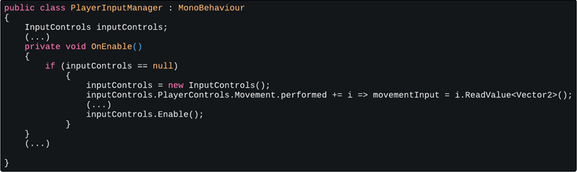
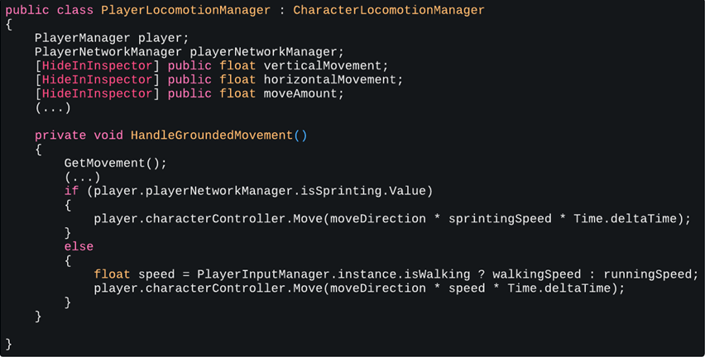
- Open/Closed Principle (OCP) – software entitites should be open for extension, but closed for modification. This means that code can be expanded upon without modifying existing code. For instance, in a script that manages character behaviour, new characters can be added by creating new classes rather than modifying existing ones.
- Liskov substitution principle – functions that use pointers or references to base classes must be able to use objects of derived classes without knowing it. This means that classes such as HealingItem or StaminaItem are derived from an Item class and they maintain all the properties of their parent class.
- Interface segregation principle – clients should not be forced to depend upon interfaces that they do not use. This creates cleaner and more focused interfaces, enhancing the understandability of the code.
- Dependency Inversion Principle (DIP) – depend upon abstractions, not concretes. This reduces dependencies between modules, making code more flexible and easier to maintain. For example, a Player class should depend on an IInputManager interface rather than directly on an InputManager class.

Recommended Folder Structure
A well-structured project should include organized folders to separate different components, such as prefabs, SFX, materials, scenes etc. Example (my project):
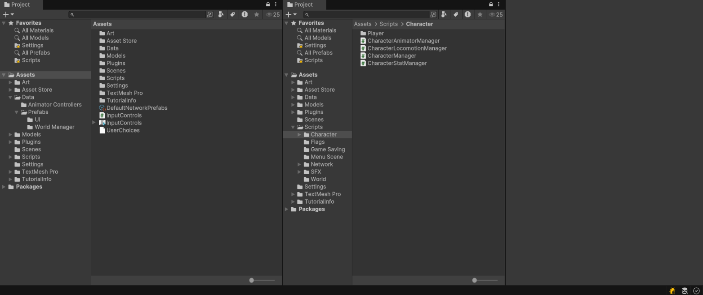
General guidelines (Best practices for organizing your Unity project, Oct 20, 2023):
- Consistent naming conventions – Don’t deviate from a chosen style guide or template. If naming rules need to be amended, parse and rename the affected assets all at once.
- Avoid extra folders at the root level – In general, content files should be stored within the Assets folder. Additional folders shouldn’t be created at the root level unless absoultely necessary
- Keep internal assets separate from third-party ones – If the projects uses assets from the Asset Store or other plug-ins, they likely have their own project structure. These should be kept seperate from personal assets.
- Document naming conventions – A style guide or project template makes files easier to locate and organize, especially for people reviewing the project / team members.

Using singletons for Global Systems
Singleton is a design pattern that allows only one instance of a class to exist which then allows any script to reference to it — fundamentally a global access to this instance. (Ray, medium.com, Jul 16 2022). Some game-wide managers, such as PlayerManager, TitleScreenManager, or SaveGameManager benefit from being implemented as Singletons, ensuring that only one instance exists.
Example: PlayerInputManager class
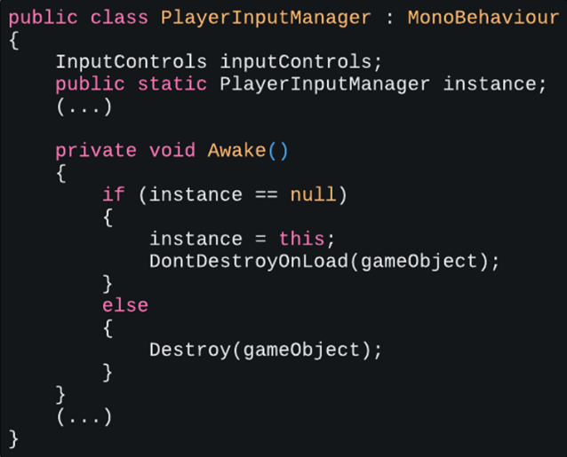
And then using the instance in a different script, PlayerCamera
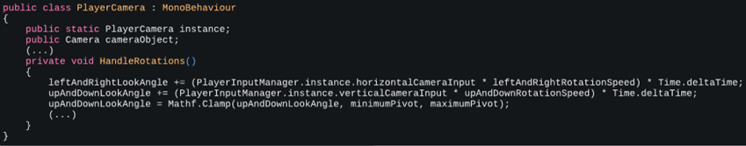

Inheritance
Inheritance allows one class to extend and modify the functionality of another (C# in Unity - Inheritance). This principle stands at the core of how I structured my scripts.
Example: PlayerManager inheriting from the CharacterManager class
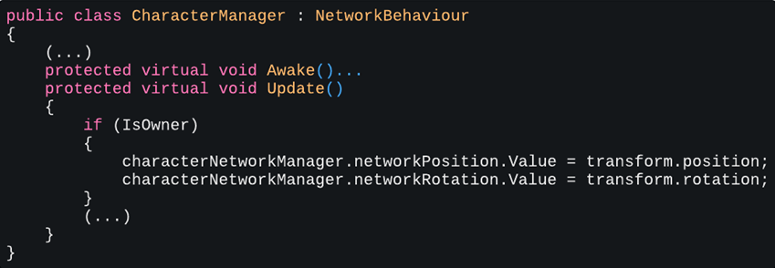
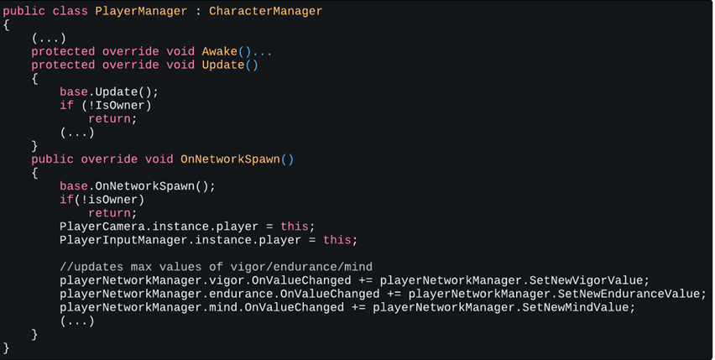

Additional Best Practices

Observer Pattern (Event System)
- The observer pattern allows objects to communicate but stay loosely coupled using a one-to-many dependency. This means that when one object changes states, all dependent objects get notified automatically.
- The object that is broadcasting is called the subject. The other objects that are listening are called the observers, or sometimes subscribers.
- Observers are simply notified whenever the subject’s state changes, allowing them to update themselves accordingly. This way, it becomes easier to modify or extend the code without affecting other parts of the system. (Create modular and maintainable code with the observer pattern)
Example: Subscribing to OnValueChanged Event to modify Player UI
And unsubscribing from them to prevent errors
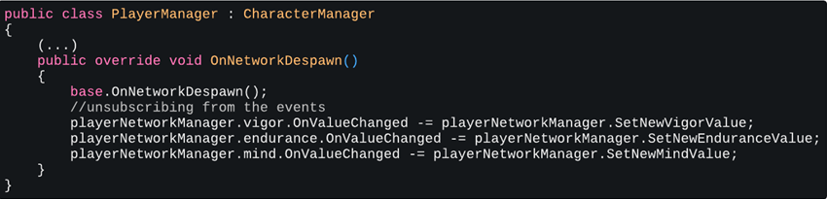

Conclusion
Code architecture is one of the most expansive subjects in the programming field, even more so in Unity, where projects can reach massive scales and can be difficult to manage at times. There is still more to analyse on the topic, with entire books being written on just Unity Architecture alone. However, I believe I have implemented the foundational patterns and principles into my project that ensure a clean and scalable codebase. As I continue to work on my project and learn how to implement new game features and mechanics, I will also learn about how to structure said features and document them in future reports.

References
- Mikael Kalms: How to Architect Code as Your Project Scales
- Best Practices for Project Organization
- Level Up Your Code with Game Programming Patterns
- The Importance and Application of SOLID Principles in Unity Game Development
- SOLID
- Game Design Pattern – Using Singletons in Unity
- C# in Unity - Inheritance
- Create modular and maintainable code with the observer pattern

